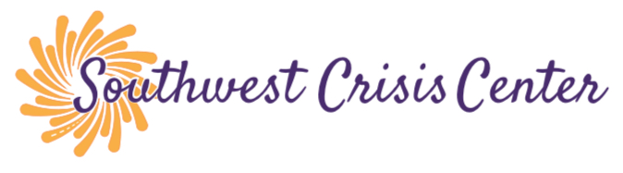

The Southwest Crisis Center is committed to providing safe services to all individuals. During this COVID – 19 Pandemic, we need to take extra precautions to help keep our staff and participants safe.

All indoor meetings, we are requiring all participants to:
-wear a mask (we will provide you with one if you do not have one)
-Have your temperature taken (100.4 or higher, we ask that they connect another way)
-answer screening questions.
-Have you been exposed
-Have you felt ill

Prior to all group meetings, the group space will be cleaned and sanitized, while meeting in groups, we will require a 6 ft. distance between participants, along with wearing a mask at all times. All supplies will be sanitized and prepared appropriately.

A zoom link will be provided for all of our meetings if the guidelines are not agreed upon.

Due to distancing guidelines, we will need to limit the number of in-person participants. We will be utilizing outdoor spaces whenever possible and weather permitting.

If you have any questions or concerns, please contact Stephanie, Youth Program Manager at 507-376-4311 or stephanie@mnswcc.org

